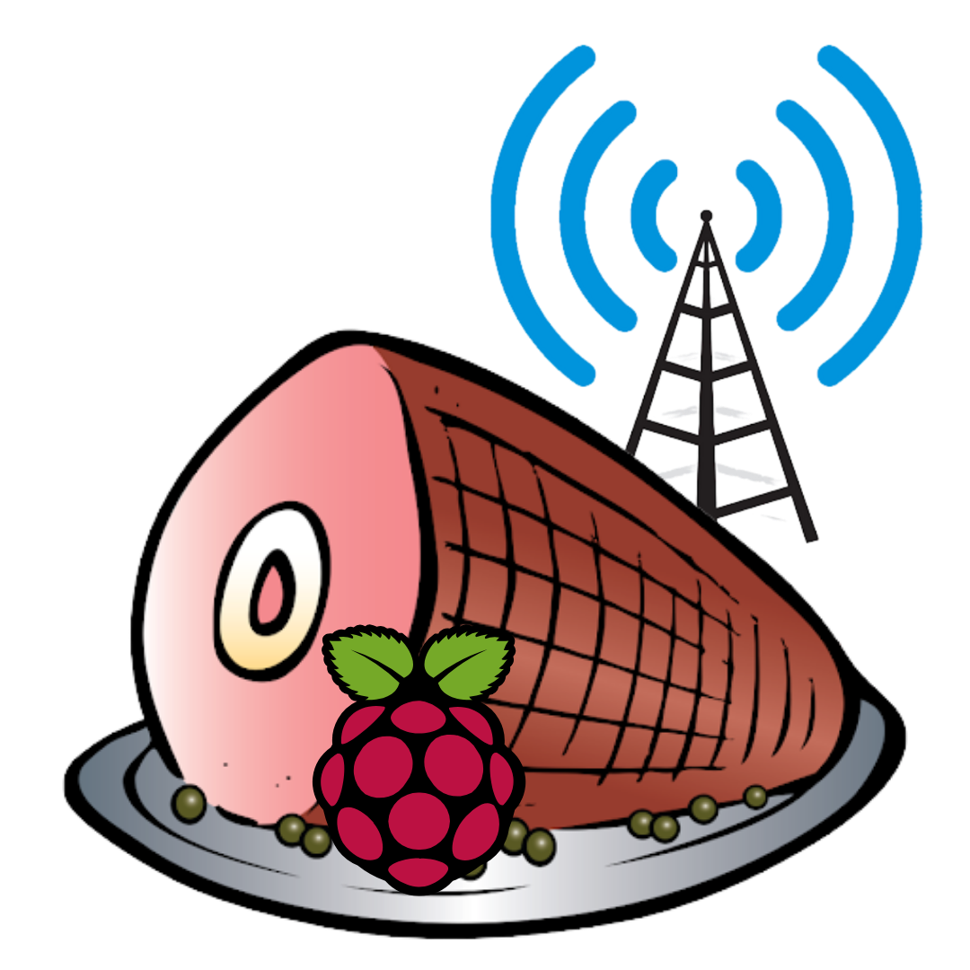Fellow Hams and Raspberry Pi Enthusiasts,

I am pleased to announce the release of *HamPi* 1.4 (June 2021) “Father’s Day Edition” – The Raspberry Pi Ham Radio Image I've been working on for the last year +.

I have confirmed this image starts up successfully on the Raspberry Pi Model 4 B. Other users have reported it also operates on the Model 3 B. A series of beta-testers have tested this and provided feedback prior to release, and I have used that feedback to make this a better image for everyone.

The primary place to download this is via BitTorrent. If you can’t, or won’t, use BitTorrent, there are a number of direct download links:

For hosting direct download sites in the past, thank you to: Norm Schklar, [WA4ZXV](https://www.qrz.com/db/WA4ZXV), William Franzin, [VE4VR](https://www.qrz.com/db/VE4VR), David Cooley, [N5XMT](https://www.qrz.com/db/N5XMT), and David Potter, [KE8OHG](https://www.qrz.com/db/KE8OHG).

A BIG thank you to my XYL, Michelle, for creating the HamPi Logo!

Please send me any comments or concerns via email to [w3djs@arrl.net](mailto:w3djs@arrl.net).

-Dave Slotter, [W3DJS](https://www.qrz.com/db/W3DJS)

ATTENTION: Please note that by running this image on your Raspberry Pi that you consent to giving your idle cpu cycles to radio telescope research, such as looking for pulsars. If you do not agree with this, then you may opt out of running BOINC for your individual use by running the boinctui command line tool. Again, this will not interfere with your usage – this only uses cpu cycles when your Raspberry Pi is idle. Disk use is also minimal. (1/1000 or less) (For what it’s worth, I also operate my Raspberry Pi 4 this way.)

HamPi 1.4 – The Raspberry Pi Ham Radio Image by W3DJS

General Ham Radio Applications

[HamLib](https://hamlib.github.io/) - Ham Radio Control Libraries

[grig](http://sourceforge.net/projects/groundstation) - graphical user interface to the Ham Radio Control Libraries

[CHIRP](https://chirp.danplanet.com/) - Radio Programming Software

[APRS Message App for JS8Call](http://m0iax.com/2019/09/25/aprs-message-app-for-js8call/) - GUI to send APRS messages via JS8Call

[QTel](https://www.svxlink.org/) - EchoLink client

[QSSTV](http://users.telenet.be/on4qz/index.html) - Slow Scan TV (e.g. "Fax")

[Gpredict](http://gpredict.oz9aec.net/) - Satellite prediction

[FreeDV](https://freedv.org/) - Free digital voice vocoder

[BlueDV](https://www.pa7lim.nl/bluedv/) - Client for D-Star and DMR

[WsprryPi - WSPR software](https://github.com/8cH9azbsFifZ/WsprryPi.git)

[ADS-B Flight Tracking Software](https://github.com/MalcolmRobb/dump1090)

[Pi3/4 Stats Monitor](http://www.w1hkj.com/pi3/) - by [W1HKJ](http://www.w1hkj.com/)

[VOACAP](https://www.qsl.net/hz1jw/voacapl/index.html) - HF propagation prediction

[GPS Support](https://gpsd.gitlab.io/gpsd/)

[wxtoimg](https://wxtoimgrestored.xyz/beta/) - NOAA weather imaging software

[twHamQTH](http://wa0eir.bcts.info/twhamqth.html) - an online callsign look up program

[twclock](http://wa0eir.bcts.info/twclock.html) - a world clock and automatic ID for amateur radio operators

[acfax](https://www.qsl.net/dl4sdc/) - Receive faxes using your radio and sound card

[colrconv](http://db0fhn.efi.fh-nuernberg.de/doku.php?id=radio:db0fhn:convers)  -  convers client with sound and ncurses color support

[D-Rats 0.3.9 (by new maintainer Maurizio Andreotti)](https://github.com/maurizioandreotti/D-Rats) - A communication tool for D-STAR

[fbb](http://www.f6fbb.org/) - Packet radio mailbox and utilities

gcb - Utility to calculate long and short path to a location

[glfer](https://www.qsl.net/in3otd/) - Spectrogram display and QRSS keyer

[Xdx](https://github.com/N0NB/xdx) is a DX-cluster client

[DXSpider](http://www.dxcluster.org/main/) - DX Cluster Server

[fccexam](https://www.qrz.com/db/AC6SL) - Study tool for USA FCC commercial radio license exams.

[gnuais / gnuaisgui](https://github.com/rubund/gnuais/) - GNU Automatic Identification System receiver

[hamexam](https://www.qrz.com/db/AC6SL) - Study guide for USA FCC amateur radio (ham radio) license examinations.

[hamfax](http://hamfax.sourceforge.net/) - Qt based shortwave fax

[inspectrum](https://github.com/miek/inspectrum) - tool for visualising captured radio signals

[predict-gsat](https://github.com/kd2bd/predict/) - Graphical Predict client

[splat](http://www.qsl.net/kd2bd/splat.html) - analyze point-to-point terrestrial RF communication links

[wwl](https://www.qrz.com/db/VA3DB) - Calculates distance and azimuth between two Maidenhead locators

[AX.25](https://github.com/ve7fet/linuxax25) – Packet Radio drivers for ax.25 protocol

[linpac](https://sourceforge.net/projects/linpac) - terminal for packet radio with mail client

[PyBOMBS](https://github.com/gnuradio/pybombs) - GNU Radio install management system

[AMBEServer](https://github.com/marrold/AMBEServer) – AMBE vocoder chip support

[HamClock](https://www.clearskyinstitute.com/ham/HamClock/) – GUI HamClock by WBOEW

[Adifmerg](https://github.com/oh7bf/adifmerg) – command-line ADIF conversion utility

[Lopora](https://www.qsl.net/pa2ohh/11lop.htm) – QRSS Beacon Reception

[Universal Ham Radio Remote](https://github.com/F4HTB/Universal_HamRadio_Remote_HTML5) (UHRR) – UHRR provides remote radio operation

[RpiTx](https://github.com/F5OEO/rpitx) -- Turns Raspberry Pi into low power transmitter

[ACARS Decoder](https://github.com/TLeconte/acarsdec) – for tracking aircraft transponders

[CygnusRFI](https://github.com/0xCoto/CygnusRFI) – RFI analysis tool for ground stations and radio telescopes)

[Update Scripts](https://github.com/dslotter/ham_radio_scripts) -- to update Fldigi suite and WSJT-X (so one doesn't have to wait for new HamPi release.)

[Radio Explorer](http://www.radioexplorer.com.ru/en/) – Displays shortwave radio broadcast schedules

[QrssPiG](https://gitlab.com/hb9fxx/qrsspig) – QRSS (Raspberry) Pi Grabber

[Minimodem](http://www.whence.com/minimodem/) – General purpose software audio FSK modem

[Orca](https://help.gnome.org/users/orca/stable/) – Screen-reading software which supports blind hams

[RBNC](https://dm3mat.darc.de/rbn/) – Reverse Beacon Network Client

[QDMR](https://dm3mat.darc.de/qdmr/) – a GUI application and command line tool to program DMR radios

[wfview](https://wfview.org/) – a program to control modern Icom ham radios

[DUDE-Star](http://www.dudetronics.com/index.php/dude-star-radio-project) – Software to RX/TX D-STAR, DMR, Fusion YSF/FCS, NXDN, P25, M17, and IAX (AllStar client)

Antenna Ham Radio Applications

[antennavis](http://www.include.gr/antennavis.html) - Antenna Visualization Software

[gsmc](https://github.com/radioteknos/gsmc.git) - A GTK Smith Chart Calculator for RF impedance matching

[nec2c](https://www.qsl.net/5b4az/) - Translation of the NEC2 FORTRAN source code to the C language

[xnecview](http://www.pa3fwm.nl/software/xnecview/) - NEC structure and gain pattern viewer

[yagiuda](https://www.dhars.org.uk/members_pages/G8WRB/) - software to analyse performance of Yagi-Uda antennas

Digital Mode Ham Radio Applications

[WSJT-X](https://physics.princeton.edu/pulsar/k1jt/wsjtx.html) - Weak Signal (FT8, FT4, etc.) by [W1JT](https://www.qrz.com/db/K1JT)

[GridTracker](https://tagloomis.com/grid-tracker/) - Graphical mapping companion program for WSJT-X or JTDX

[JTDX](http://www.jtdx.tech/en/) - Alternate client for Weak Signal (FT8, FT4, etc.)

[JS8Call](http://js8call.com/) - Messaging built on top of FT8 protocol by [KN4CRD](https://www.qrz.com/db/kn4crd/)

[JS8CallTools](http://m0iax.com/2019/05/27/js8calltools-for-raspberry-pi/) - Get Grid coordinates using GPS

(FLDigi is in its own section below.)

[gnss-sdr](https://github.com/gnss-sdr/gnss-sdr) - GLONASS satellite system Software Defined Receiver

[linpsk](http://linpsk.sourceforge.net/) - amateur radio PSK31/RTTY program via soundcard

[multimon](https://sourceforge.net/projects/multimon/) - multimon - program to decode radio transmissions

[multimon-ng](https://github.com/EliasOenal/multimon-ng) - digital radio transmission decoder

[psk31lx](http://wa0eir.bcts.info/psk31lx.html) - a terminal based ncurses program for psk31

[twpsk](http://wa0eir.bcts.info/twpsk.html) - a psk program

Software Defined Radio

[CubicSDR](https://cubicsdr.com/) - Software Defined Radio receiver  
[cutesdr](https://sourceforge.net/projects/cutesdr/) - Simple demodulation and spectrum display program

[GQRX](http://gqrx.dk/) - Software defined radio receiver

[LeanSDR](https://github.com/pabr/leansdr) – Lightweight, portable software defined radio

[SDRAngel](https://github.com/f4exb/sdrangel) - SDR player

[lysdr](https://github.com/gordonjcp/lysdr) - Simple software-defined radio

[SoapyAudio](https://github.com/pothosware/SoapyAudio) - Soapy SDR plugin for Audio devices  
[SoapyHackRF](https://github.com/pothosware/SoapyHackRF) - SoapySDR HackRF module  
[SoapyMultiSDR](https://github.com/pothosware/SoapyMultiSDR) - Multi-device support module for SoapySDR  
[SoapyNetSDR](https://github.com/pothosware/SoapyNetSDR) - Soapy SDR module for NetSDR protocol  
[SoapyRemote](https://github.com/pothosware/SoapyRemote) - Use any Soapy SDR remotely  
[SoapyRTLSDR](https://github.com/pothosware/SoapyRTLSDR) - Soapy SDR module for RTL SDR USB dongle

[SoapySDR](https://github.com/pothosware/SoapySDR) - Vendor and platform neutral SDR support library

[SoapySDRPlay](https://github.com/pothosware/SoapySDRPlay) - Soapy SDR module for SDRPlay

Support for [RTL-SDR](https://www.rtl-sdr.com/)

Support for [SDRPlay SDR](https://www.sdrplay.com/)

Support for [HackRF SDR](https://greatscottgadgets.com/hackrf/)

Support for [AirSpy](https://github.com/airspy/airspyone_host) and [AirSpy HF](https://github.com/airspy/airspyhf)

[SoapySDRAirSpy](https://github.com/pothosware/SoapyAirspy)- Soapy SDR module for AirSpy SDR

[SoapySDRFUNcube Dongle Pro+](https://github.com/pothosware/SoapyFCDPP)- Soapy SDR module for FUNCube Dongle Pro+

[SoapySDRPlutoSDR](https://github.com/pothosware/SoapyPlutoSDR)- Soapy SDR module for Pluto SDR

[SoapySDROsmoSDR](https://github.com/pothosware/SoapyOsmo)- Soapy SDR module for Osmo SDR

[SoapySDRRedPitaya](https://github.com/pothosware/SoapyRedPitaya)- Soapy SDR module for Red Pitaya SDR

[SoapyUHD](https://github.com/pothosware/SoapyUHD)- Soapy SDR module for Ettus ResearchUHD SDR

[SoapySDRVOLKConverters](https://github.com/pothosware/SoapyVOLKConverters) - Support for VOLK-based type converters

APRS Applications

[Xastir](http://xastir.org/) - APRS GUI client / Digipeater / Igate

[YAAC](https://www.ka2ddo.org/ka2ddo/YAAC.html) - Yet Another APRS Client

[DireWolf](https://github.com/wb2osz/direwolf) - Software "soundcard" AX.25 packet modem/TNC and APRS encoder/decoder

[aprsdigi](https://github.com/n2ygk/aprsdigi) - digipeater for APRS

[aprx](https://thelifeofkenneth.com/aprx/) - APRS Digipeater and iGate

[soundmodem](http://soundmodem.vk4msl.id.au/) - Sound Card Amateur Packet Radio Modems

FLDigi Application Suite from [W1HKJ](http://www.w1hkj.com/)

[flrig](http://www.w1hkj.com/) - Rig Control program which interfaces with fldigi

[fldigi](http://www.w1hkj.com/) - [Digital Modes](http://www.w1hkj.com/modes/index.htm) Communications

[flaa](http://www.w1hkj.com/) - RigExpert Antenna Analyzer Control Program

[flamp](http://www.w1hkj.com/) - File transmissions via Amateur Multicast Protocol

[flarq](http://www.w1hkj.com/) - ARQ data transfer utility for fldigi

[flcluster](http://www.w1hkj.com/) - Telnet client to remote DX Cluster Servers

[fllog](http://www.w1hkj.com/) - Logbook application which can use same data file as fldigi

[flmsg](http://www.w1hkj.com/) - Editor for ICS 213 Forms

[flnet](http://www.w1hkj.com/) - Net Control Assistant for Net Activities (Check-In Application)

[flpost](http://www.w1hkj.com/alpha/flpost/) - NBEMs post office

[flwrap](http://www.w1hkj.com/) - File encapsulation and compression for transmission over amateur radio

[flwkey](http://www.w1hkj.com/) - Winkeyer (or clone) control program for K1EL Winkeyer series

Logging Applications

[TrustedQSL](http://www.arrl.org/tqsl-download) - LotW client

[CQRlog](https://www.cqrlog.com/) - Ham Radio Logging Application

[PyQSO](https://christianjacobs.uk/pyqso/) - Logging software (written in Python)

[klog](https://www.klog.xyz/) - The Ham Radio Logging program

[SKCCLogger](http://www.ac2c.net/Downloads.php) – Straight Key Century Club Logging application

[tlf](https://tlf.github.io/) - console based ham radio contest logger

[tucnak2](http://tucnak.nagano.cz/wiki/Main_Page) - VHF/UHF/SHF Hamradio contest log version 2

[twlog](http://wa0eir.bcts.info/twlog.html) - basic logging program for ham radio

[upload_adif_log](https://github.com/dslotter/ham_radio_scripts) – Upload only new log entries to LotW, eQSL.cc and ClubLog

[update_wsjtx_log.py](https://github.com/dslotter/ham_radio_scripts) – Updates missing name and/or grid square in WSJT-X ADIF logfile

[wsjtx_to_n3fjp](https://github.com/dslotter/wsjtx_to_n3fjp) - Logging adapter to allow WSJT-X to log to N3FJP

[xlog](https://www.nongnu.org/xlog/) - GTK+ Logging program for Hamradio Operators

WinLink Applications

[Pat WinLink](https://getpat.io/) - WinLink for Raspberry Pi (and other platforms)

[ARDOP](http://www.cantab.net/users/john.wiseman/Documents/ARDOPC.html) support for Pat WinLink

[ARDOP-GUI](https://www.cantab.net/users/john.wiseman/Downloads/Beta/) - Provides graphical representation of ARDOP connections

[Find ARDOP](https://app.simplenote.com/publish/LR0lxm) - Retrieves local ARDOP sources by [KM4ACK](https://www.qrz.com/db/KM4ACK)

[Pat Menu 2](https://github.com/km4ack/patmenu2) – Menu for Pat by KM4ACK

[PMON](https://www.p4dragon.com/en/PMON.html) - a PACTOR® Monitoring Utility for Linux

Morse Code Applications

[aldo](https://www.nongnu.org/aldo/) - Morse code training program

[cw](http://unixcw.sourceforge.net/about.html) - sound characters as Morse code on the soundcard or console speaker

[cwcp](http://unixcw.sourceforge.net/) - Text based Morse tutor program

[xcwcp](http://unixcw.sourceforge.net/) - Graphical Morse tutor program

[cwdaemon](http://cwdaemon.sourceforge.net/) - morse daemon for the serial or parallel port

[ebook2cw](https://fkurz.net/ham/ebook2cw.html) - convert ebooks to Morse MP3s/OGGs  
[ebook2cwgui](http://fkurz.net/ham/ebook2cw.html) - GUI for ebook2cw

[morse](http://www.catb.org/~esr/morse-classic/) - training program about morse-code for aspiring radio hams

[morse2ascii](http://aluigi.altervista.org/mytoolz.htm) - tool for decoding the morse codes from a PCM WAV file

[morsegen](http://aluigi.altervista.org/mytoolz.htm) - convert file to ASCII morse code

[qrq](https://fkurz.net/ham/qrq.html) - High speed Morse telegraphy trainer

[xdemorse](https://launchpad.net/ubuntu/+source/xdemorse/3.4-1) - decode Morse signals to text

*** Ham Radio Wallpaper also included in image ***

*** Help menu items available off the main desktop GUI menu ***